2022 Major Review of Australian Standard Classification of Religious Groups (ASCRG) and Religious Affiliation Standard (RAS)

Survey Questions

- What is your name?
How ABS manages your privacy: Privacy at the ABS | Australian Bureau of Statistics

- Please ensure that you include contact details in your submission. By providing this information, you agree that the ABS can contact you to ask any follow-up questions, if required.
- What is your email address and contact phone number?
- What is your organisation?

- Which state or territory do you live in?
  - ACT
  - NSW
  - NT
  - QLD
  - SA
  - TAS
  - VIC
  - WA
  - Outside Australia (please specify)

- How did you find out about the 2022 review of ASCRG and RAS?

  - Direct approach from the Australian Bureau of Statistics (ABS)
  - Direct approach from another government agency
  - Found information on the ABS website
  - Stakeholder network
  - Personal networks
  - Other (please specify)

- What does your feedback relate to?
  - Religious Affiliation Standard (RAS; the way the question is asked in the Census of Population and Housing)
  - ASCRG (Classification)
  - Both
Your answers to the questions below will be used to inform the review and preparation for the 2026 Census.

- The Census of Population and Housing asks a question about a person’s religion, with the paper form shown below. In response, a person can either mark a check box on the pick list; or write their response in a text box (Other, please specify).

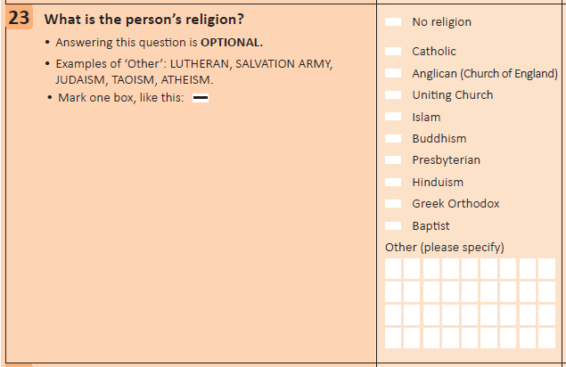

- Does the way this Religious Affiliation question is asked impact you or your community?

If “yes”, provide a description of why and how this impact occurs.

- Do you have any other feedback on RAS?

- Please list any religious groups that are not accurately represented in the ASCRG.

In the ASCRG a religious group is the most detailed level of the classification and has a four-digit code.

For each religious group that is not accurately represented, please provide your suggestions for the following:
- Accurate title
- Describe the religious group’s beliefs and practices, and relationship to other religious groups.
- Please include evidence to support the proposed change; for example surveys or data that indicate the number of people affiliated with the group.

- Is there a group that is not currently identified as a Religious Group (the four digit level) in the ASCRG that should be identified separately?
For example, is there a group within Buddhism (1011) or Hinduism (3011) that should be created as a separate Religious Group in the ASCRG?

For each group, please provide the following information:
- Describe the group’s beliefs and practices, and relationship to other, similar groups.
- Indicate the number of people that are affiliated with the group you are proposing should be separately identified. What is the source/basis for your estimate?
- Outline how you currently classify this group using the existing classification
- Would adding this group to a ‘Not Elsewhere Classified’ category in the classification meet the needs of this group? Why, why not?
- Explain how the omission of this Religious Group as a separate category in ASCRG impacts the community (link to the ASCRG webpage)

- Do you use Census religious affiliation data?
- No
- Yes

If “Yes”, please provide the following:

- Please describe how you/your organisation uses the religious affiliation data from the Census. For example, is the data used for any policy analysis, development or reporting purposes?
- Do you have any concerns about the quality of data collected by RAS?
- Do you find there are limitations when using the data?
- Is there any additional analysis or reporting that you would like to do using Religious Affiliation data? Please provide a description.

- Are there any other comments you would like to provide regarding this review? (Word limit 500)

If you have any questions about this consultation process, please email standards@abs.gov.au

