Major Review of the Australian Standard Classification of Religious Groups (ASCRG) and Religious Affiliation Standard (RAS)

Scope of review

Commencing 2022, the ABS is embarking on a major review of ASCRG and the RAS. In a major review, all known issues and concerns are considered for possible change. The updated ASCRG is currently scheduled for release in December 2023.
Any updates to the RAS will be released after the Census content consultation has occurred and the question has been tested. This will occur prior to the 2026 Census.
In addition, a general review of Census content will occur in parallel to this review; and will also include public consultation. The review of ASCRG and RAS will provide input into the broader review of Census.

To understand the need for this review, the ABS has undertaken a range of research and analysis, including:
- Feedback already received from individuals and organisations.
- Research into how people have responded to the Religious Affiliation question in previous Censuses.
- Issues identified through standard classification maintenance processes, including consideration of the classification criteria.
- Comparison with other religion classifications and standards used by demographically similar countries (e.g. StatsCan and StatsNZ).
This research has informed some initial areas that are in-scope of this review, outlined below.

The ABS invites you to provide feedback on the initial areas that have been identified as in-scope of this review (i.e. whether you consider these areas as high or low priority). In addition, the ABS invites you to provide feedback on any other key areas of concern that should be included in the review, that are not already outlined below.

In-scope
- Investigation of the RAS
The Census of Population and Housing asks a question about a person’s religion, shown below. In response, a person can either mark a box on the pick list; or write their response in a text box (Other, please specify).
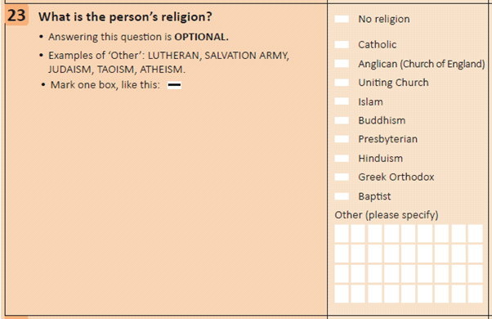
There are a number of areas for investigation with respect to the RAS, in particular:

a. Can the response options be changed to be more inclusive?
The pick list was designed to make completing Census forms easier and is similar to other Census questions (e.g. Country of birth). The pick list includes the ten most frequently reported groups from the previous Census. However, feedback indicates that people not affiliated with any of the groups in this list feel excluded.

In addition, some people report feeling compelled to mark a box on the pick list, which did not necessarily reflect their religious affiliation. For example, people affiliated with the Macedonian Orthodox religious group felt they were being asked to mark the Greek Orthodox box because it was in the pick list and Macedonian Orthodox was not.

Although a large number of other religious groups are included in the classification, most people only see the Census form. The full classification is available in the Further Information section, below.

b. Consistency between the question wording and the pick list options.
Another issue that has been raised, in relation to the question wording and the pick list, is the inconsistency in terminology used. For example, the question asks about a person’s religion; however, the options in the pick list include both world religions (e.g. Islam, Buddhism) and denominations (sub-groups or branches of a world religion, e.g. Catholic, Anglican).

This review will consult with stakeholders to investigate possible alternatives to the current question, pick list and text response.

- Investigation into Islam, Buddhism, Hinduism, and Judaism; and whether it is possible to identify additional religious groups.
The ABS has received feedback regarding the imbalance in the number of Christian groups represented in the ASCRG in comparison to other religions. The current representation of these groups can be found in the full classification, in the Further Information section below.

In consultation with relevant communities and other stakeholders, this review will examine whether it is possible to identify sub-groups within these religions for inclusion in the ASCRG at the Religious Group (four digit) or Narrow Group (two or three digits) levels.

- Investigation into how Christian Orthodox groups appear in the ASCRG and the RAS.
The ABS has received feedback regarding how Christian Orthodox groups are represented in both the ASCRG and RAS. For example, in the current classification, a number of Christian Orthodox groups are recognised under the Oriental Orthodox (221) and Eastern Orthodox (223) Narrow Groups. However, only Greek Orthodox is included as an option in the pick list on the Census form. This is seen as excluding people who are affiliated with the other Christian Orthodox groups.

Feedback suggests that a more appropriate way to represent all people affiliated with the Christian Orthodox faith is to represent them as one group (Christian Orthodox). This review will investigate this issue, in consultation with relevant communities and other stakeholders. Note that there is some overlap here with the issues outlined in part 1, above.

The current representation of Christian Orthodox groups is available in the full classification, in the Further Information section below.

- Investigation into a possible restructure of the classification codes.
In the current classification, a two digit (e.g. Pentecostal Religions, code 24) or three digit code (e.g. Anglican religions, code 201) is a Narrow Group.

In consultation with stakeholders and data users, this review will investigate the current code structure. The aim is to determine whether an alternative can be found, where all Narrow groups have the same code length (i.e. two or three digit).

- Investigation into the structure of Broad Group 7, Secular Beliefs and Other Spiritual Beliefs and No Religious Affiliation.
A number of issues have been identified in this group, including:
- Should Broad Group 7 continue to be included in a classification of religious groups?
- Should ‘Secular Beliefs’ (e.g. Agnosticism, Atheism) continue to be distinguished from ‘No Religion’?

The current representation of the Broad Group 7, Secular Beliefs and Other Spiritual Beliefs and No Religious Affiliation can be found in the full classification, in the Further Information section below. This review will investigate this issue, in consultation with relevant communities and other stakeholders.

Out of scope
Changes to the underpinning conceptual content to include 'participation' as well as 'affiliation'.
The current concept underpinning the ASCRG, and the RAS is religious affiliation. That is, the religious or spiritual beliefs or practices to which a person adheres or the religious group to which a person belongs.
The ABS has no plans to change the underlying concept of the ASCRG and RAS.

Investigation of or changes to other, related classifications
A number of other classifications are closely related to the ASCRG: Australian Standard Classification of Countries (SACC), Australian Standard Classification of Cultural and Ethnic Groups (ASCCEG) and Australian Standard Classification of Languages (ASCL). During the religion review issues may be identified that also affect these 3 other classifications. Where this occurs, issues will be documented for consideration in future reviews of these other related classifications.

The ABS anticipates undertaking reviews of these related classifications prior to the 2026 Census. Further detail will be made available on the ABS website in coming months.

Further information
For further information regarding the major review, please see the links below:
- Religious Affiliation Standard, 2016 | Australian Bureau of Statistics (abs.gov.au)
- Australian Standard Classification of Religious Groups, 2016 | Australian Bureau of Statistics (abs.gov.au).
- The full classification can be found in the Data downloads section of the Australian Standard Classification of Religious Groups, 2016 webpage (linked above). It is also available here (Table 1.3):

For additional information, email the ABS at: standards@abs.gov.au

